Title or Task: | HWT113 The Digital Home  
Description: | Holiday Homework
Files Required | Course Book, MS Word & Internet
Suitable for Classes: | All classes
Area: | Technology & Enterprise
Teacher: | Mr Peter Faulks
Timeline | One week
Date Due: | Week 1 of Term 2
Task Brief: | Short answer homework
Outcomes: | Improve ICT knowledge base

Items highlighted in yellow are tasks for you to complete
Items in Blue italics are help tips

Worksheet Homework Week 1 term 2

Short answer questions return by Friday of week 1 Term 2

Your Name:

Course :

Questions

HWT113 The Digital Home 100 Marks

The digital home THIS IS HOMEWORK for term holidays

print me out and take me home…
You are to research the impact of technology in your home, and will need to consider advantages or disadvantages that technology has created:

- Look at the types of digital technology that has been replaced in the home environment (give at least two items in three rooms or you may use one room to record several items but give examples from at least two rooms)

What you need to do:
The Digital Home

Homework DIGITAL HOME save this document as

- Headers and Footers = Replace teachers name with your name and change the footer.
- Complete the tables.
- Answer questions 4 & 5 in essay format.
- This piece of work should be no more than 400 words in length.
- (Electronic) Save you work as (your initials WKS123_surname_Initial.doc
(Surname = Your surname and Initial)
i.e. if your name was Poly Carbon you would save this document as

WKS123_Carbon_P.doc e in your web marking file or to the thumb drive or print out (not recommended)
- Hand me your homework by due date -25% if late and -2% per day thereafter
10 Marks
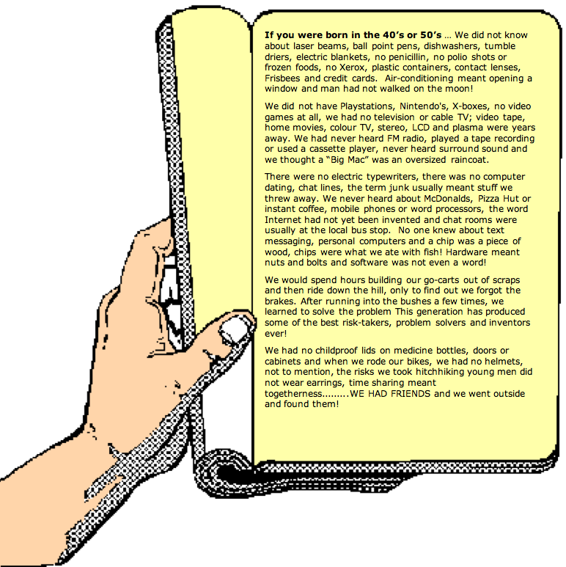

1. Your name=

Completed the following pages…
- In the tables, below find three (3) rooms in your house where technological items Microwave, Fridge, Cooker, TV, Video, Computers etc. have been replaced by new items.
- list any two (2) items of equipment that, over the past twenty or so years has been replaced by new technology in this room.

Room 1___________________________
Lounge / Kitchen / Study / Your Room / other Room _____________________
Old Equipment | Replaced By
1 Cassette tapes and records | IPods  Mp3 players
Advantages of the technology

hard drive-based iPods classic, the touch screen iPod touch, the video-capable iPod nano and the screen less iPod shuffle

Disadvantages of the technology

Cassette damaged easily wear out quickly

Old Equipment | Replaced By
2 Tape Recorders | Digital Sound
Advantages of the technology

Digital recording brought optical playback using lasers, which basically meant that the use of laser to read digital information on a disc did not ruin or damage the information on the disc even if used continually. The quality of digital storage is clear as ever piece of information stored on the disc is read and processed exactly as it was recorded.

Disadvantages of the technology

Tape cassettes have been affected by Digital convergence, as music was once distributed and played on them, but about 20 years ago, came the introduction of the Compact disc. Basically cassettes work exactly the same as how a video tape works; a ribbon of tape is wound on spools which rotate. The equipment which used to play the tape contributed to the down fall of the cassette tape as the more times the tape was played, the worse the quality of it became.

Audio |  |  |  | Megabytes  Gigabytes  Touch screen  Some play movies, and videos, television, internet.
Clock |  | Digital clock | 24 notation with hrs ranging from 00-23  12 hour notation with AM/PM indicator  Most digital clocks use an LCD, LED or VFD display | Analogue clocks usually indicate time using angles. The most common clock face uses a fixed numbered dial or dials and moving hand or hands. It usually has a circular scale of 12 hours, which can also serve as a scale of 60 minutes, and 60 seconds if the clock has a second hand.
Thermometers | Analogue-  Alcohol and mercury | Digital and electronic | Home thermometers are more compact, smaller and are hand held ear thermometers which make it much easier to use.

10 marks

Room 2 _______________________
Lounge / Kitchen / Your Room / other Room _____________________
Old Equipment | Replaced By
1  Analogue clock with round face | Digital and electronic time
Advantages of the technology

Home thermometers are more compact, smaller and are hand held ear thermometers which make it much easier to use.

Disadvantages of the technology

Have to wound up or battery, dial or dials and moving hand or hands. It usually has a circular scale of 12 hours, which can also serve as a scale of 60 minutes, and 60 seconds if the clock has a second hand.

Old Equipment | Replaced By
2  Thermometers | and weather
Advantages of the technology

Home thermometers are more compact, smaller and are hand held near thermometers which make it much easier to use.

Disadvantages of the technology

Analogue-
Alcohol and mercury

10 marks

Room 3 ____________________________

Lounge / Kitchen / Your Room / other Room _____________________
Old Equipment | Replaced By
1 Wireless Radio | Computers
Advantages of the technology
Computers have also been affected by digital convergence, as before televisions were quite simple and the early computer industry adopted a vertical structure.
Each manufacturer designed its own system around a proprietary architecture. They often developed and produced their own semiconductor devices for memory and processing, and employed their own applications software. Manufacturers also directly controlled the sales and distribution of their machines. By the late 1970s, rapidly developing microprocessor technology put all the basic processing functions of a computer on a single chip. Computers began to be assembled around a microprocessor, supplemented by readily available components such as memory chips, I/O controllers, disc drives, and peripherals. In 2008, although computers are still very much assembled around the basic functions, we are able to do a lot more on them. We can download movies, music, television shows, send emails to people all round the world almost immediately, and we are able to create graphics, manipulate photo’s and images and even go onto the internet for entertainment or to learn. But in 2008, our computer had become more complex in such a way that we are able to take our computers with us whenever we want, and computers today are much slimmer and smaller to not only appeal to different ages, but for convenience.

Disadvantages of the technology
Poor quality

Old Equipment | Replaced By
2 Newspapers | Computer Generated news web based
Advantages of the technology

More and more people will reply less on newspapers, television and music and will start relying more and more on their phones, which conveniently you are able to not only read up on the news, but also watch television shows of your own choice and listen to the music you want to listen to. Our society will become very independent and self- sufficient as we will be making our own decisions when it comes to what we like. I think that newspapers will eventually phase out, as more and more people if not reading up on the news on the Internet, will look up the news on their phones, or watch it on their televisions. As far as televisions go, you are able to access a television where ever you want one, for example in a car, or even on your fridge. Televisions are becoming more technological complex as they are continually being developed, for example the picture has come a long way from analogue, now we have LCD’s and Plasma televisions. Not only do we all have the four commercial channels, people have the choice to purchase Foxtel. Foxtel not only enables you to chose your own messages, but it allows you to pause live television, which is beneficial, because if you need to take a break you are able to pause and come back to where you paused from. I-pods and I-tunes have enabled people to rely more on the computer for music, then CDs and tapes. I-pods are defiantly more portable which enables people to take their music wherever they want and listen to what ever they want. Less and less people will buy CD’s and use the Internet more and more. Music will improve more as digital recording and playback provides a higher quality product. Given the right hardware and software, digital copies of music and images can be so good, they are indistinguishable from the originals.

Disadvantages of the technology
New products will come out all the time, and the cost of upgrading will become more and more expensive, especially when you are in the business of say multimedia because software is continually coming out. Because the newer software can be bigger in size and more powerful, most of the time you would need to upgrade your computer so the software run a lot faster.

10 marks

Write up a summary of your home technology

4. A brief description of the digital technology in your home with specifications
write here i.e. Television LCD 42” 100Hz, HDMI inputs etc.

aswers will vary

40 Marks

5. A list of the specifications on the computer system you use either in your room or the family computer.(All Programs)
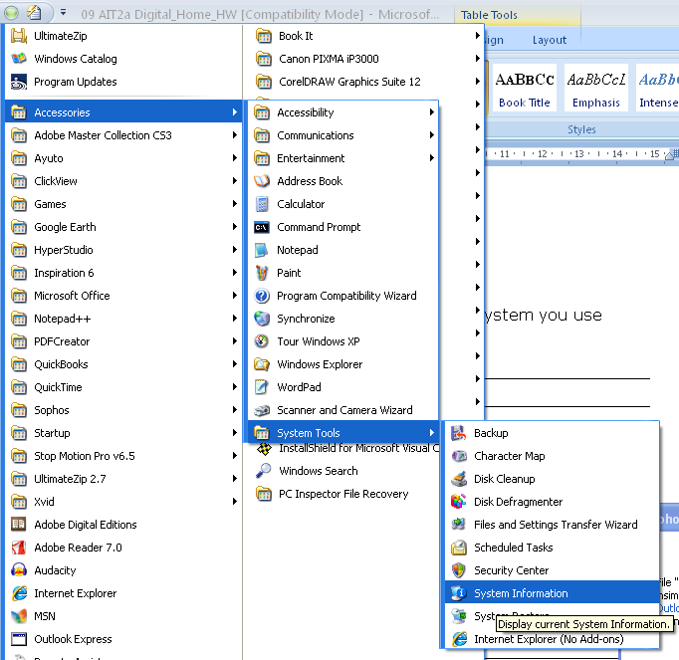

For Mac Click on Blue Apple and About this Macintosh

Write here
Answers will vary

20 Marks

